

presents

Script V1
for the production of a

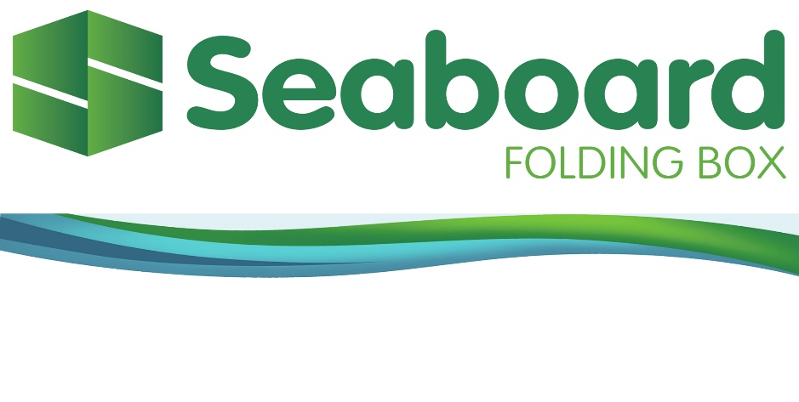

Virtual Tour Sales Video

Running Time As Written: 968 words @ 120 words per minute = 8:04

2096-SEABOARD Script V1.docx
January 6th, 2022

FADE UP ON: SEABOARD Logo – hold 4 seconds.

FADE TO BLACK for 2 seconds
Music UP

FADE UP on the up-tempo music and a 5-second rapid-fire visual sequence featuring manufacturing close-ups epitomizing Speed, … Quality, … and Capacity.

GRAPHIC TEXT:
SPEED, … QUALITY, … CAPACITY

Once narration begins, the fast-paced visual sequence highlights SEABOARD operations, processes, people and products. The visual theme is action, energy and technology.

Narrator: SEABOARD FOLDING BOX COMPANY is a full-service provider of custom structural packaging with extensive design, pre-press, printing and finishing capabilities. Headquartered in Westminster, Massachusetts, just an hour West of Boston, the 190,000 square foot, modern facility is strategically located to serve the busy Northeast corridor, the Eastern SEABOARD and is now penetrating markets in the Midwest, as well.

Leveraging a 60-plus year track record, and a continuous investment in technologies, human resources and infrastructure enables SEABOARD to fabricate an endless variety of high-quality, made-to-order packaging for a variety of customers. SEABOARD’s highly experienced workforce delivers quick-turnaround times with flexible scheduling, while maintaining the premium quality standard that SEABOARD is known for.

Photos showing applications in various industries mentioned.

Serving the Food, … Pharma, … Personal Care, … and Hardware industry segments, the diversified, colorful, and innovative capabilities SEABOARD offers, allow customers to bring a high quality, attractive and unique package to market.

Interior overviews of operations.

Since 1954, SEABOARD has grown its in-house manufacturing capabilities.

Continuous investment in people, automation, and new facilities, paired with highly strategic customer partnerships have established SEABOARD as a proven leader with new and existing customers.

Interior plant overviews – all Production Departments including Sheeting, Printing, Die Cutting and Finishing.

GRAPHIC TEXT Scroll:
- 2 – Maxon Sheeters
- 1 – Heidelberg 8-Color Offset Press
- 1 – Heidelberg 6-Color Offset Press
- 4 – Bobst Diecutters
- 9 – Folder/Gluers
- 3 – Carton Packers

The Company’s extensive and automated production capabilities support the Sheeting, … Printing, … Die Cutting, … and Finishing departments. With excess capacity in all departments and an additional 70,000 square feet of space available for expansion, SEABOARD is prepared for continued growth and profitability. The Company currently operates at XX% capacity on a single shift, with a production target of just under 1.4 million pieces a day.

MANUFACTURING operations in action. `

SHEETING DEPARTMENT
GRAPHIC TEXT Scroll:

SHEETING

Sheeting operations, featuring Maxson sheeters.

Sheeting is one of four main manufacturing competencies at SEABOARD. Production begins with large rolls of sheeting material that eventually become the finished box. To begin, the rolls are loaded into one of two Maxson sheeters which feed the dual-rotary cutting station. Machine operations and setup are completed with the intuitive touch-screen control panel. This sheeter allows a maximum sheet size of 65 inches and runs at a maximum of 1,300 feet per minute. Controlled by one operator, the sheeter is setup for fast job changes, resulting in increased runtime and productivity.

PRINTING DEPARTMENT
GRAPHIC TEXT Scroll:

PRINTING

Printing operations, featuring the Heidelberg Model XL 106

Printing of the sheet material is a significant operation requiring speed, accuracy, and precise color management, … consistently. Heidelberg is the unrivaled leader of offset printing presses, and SEABOARD operates two of the smart machines – the most highly automated and most intelligent Speedmasters ever – both the 6-color, Model CD 102, … and the 8-color Model XL 106. With 28-inch by 40-inch capacities, the two presses are the heart of operational productivity and efficiency, delivering anywhere from 15,000 to 18,000 printed sheets per hour. Advanced digital controls and precise mechanical capabilities allow semi-automatic changeover from job to job, in under 2 minutes.

DIE CUTTING DEPARTMENT
GRAPHIC TEXT Scroll:

DIE CUTTING

Die cutting operations, featuring the Bobst Model Expertcut 106

The folding carton market is set to reach over 150 billion dollars by 2024 (Smithers Pira). In order to grow its share of this booming market, SEABOARD employs four Bobst Diecutters, featuring the Bobst Model Expertcut 106. The Model 106 features minimized setting time, … unmatched cut-to-print register, … unique stripping and blanking, … automatic sheet insertion, … cutting, stripping & blanking up to 9,000 sheets per hour, … high flexibility for short runs, … non-stop production for long runs, … a pallet changer and microprocessor controls, … and, can store up to 5,000 job set-ups to minimize setting time.

FINISHING DEPARTMENT
GRAPHIC TEXT Scroll:

FINISHING

Folding

Gluing

Windowing

Carton Packing

Overview of Finishing Department

Folding, … Gluing, … Windowing, … and Carton Packing make up the Finishing Department at SEABOARD. The Company’s wide variety of ﬁnished goods requires a modern, eﬃcient and automated approach to these critical post-production operations.

DGM Model 1100 SL folder/gluer in operation

9 folder gluers, including the DGM Model 1100SL high-speed Folder/Gluer shown here, complete the actual package manufacturing process, including the Tamarack Windowing capability. Maximizing throughput at 500 pieces per minute, the process includes input feed, side register blank alignment, pre-folding, transfer and front fold, bump and turn 90 degrees, upper and lower gluing, folding, closing, electronic counter and batch marker, cornering and pressing.

Final inspection/quality/color check/magnification

Quality control begins with incoming materials evaluation and proceeds through continuous and automatic error-prooﬁng throughout production. Final inspection includes color check prior to packing.

Packing equipment in action

The J-Pack automatic carton packer and two semi-automatic Ergosa Universal Packers efficiently pack cartons that are ready for shipping to the customer, or for placement in SEABOARD’s warehouse inventory storage facility.

Raw Materials and Finished Goods/Inventory

The Company’s warehousing area encompasses both raw materials storage as well as finished inventory. SEABOARDS’s integrated production management software controls and monitors production flow, inventory levels, logistics, including Just in Time shipping to the customer. The Epicor scheduling system facilitates forecasting and master production scheduling and provides day-to-day control as well as long range planning for improved lead times.

Engineering/Pre-Press/Scheduling

At SEABOARD, developing and advancing the packaging concept to the finished package is an artform. New product development for structural and functional properties, as well as aesthetics, drive the process. In-house graphics support the steps that begin with package design, then proceed through engineering to printing plate prep and fabrication. Electronic scheduling keeps development on track, and on time.

Ink Room & Scrap Recycling Operations

SEABOARD prides itself on a corporate culture focused on the future. The fact that ink mixing is done in-house not only assures quality and consistency from batch-to-batch, but advances the Company’s quest for vertical integration. The use of soy-based inks make paper easier to recycle and they release far fewer VOCs into the air, improving the air quality for our employees. The Company recycles the wood, metal and plastic used in our production processes.

Die-cut Tool Preparation

Die-cut tool preparation is also kept in-house; skilled tool-makers construct the steel-rule cutting tools to precision specifications, assuring box dimensions meet exacting customer criteria, while vastly decreasing the turnaround time from design to actual production.

Overview of general areas.
GRAPHIC TEXT Scroll: (or show their logos/symbols).

ISO 9001: 2015 Certified

FSC (Forest Stewardship Council) Certified

SQF Direct Food Quality Certified

SEABOARD is also ISO 9001:2015 Certified, … FSC Certified, … and, holds an SQF Direct Food Quality Code designation, further demonstrating the Company’s commitment to exceptional quality, through consistent and effective processes and procedures, as well as a commitment to innovation, new technology and unrivaled customer service.

FADE UP on the up-tempo music and a 5-second rapid-fire visual sequence featuring manufacturing close-ups epitomizing Speed, … Quality, … and Capacity.

GRAPHIC TEXT:
SPEED, … QUALITY, … CAPACITY

GRAPHIC:

SEABOARD logo

Music up and out.

Logo fades to Black.

